## 

## 

|  |
| --- |
| **International School**  CAPSTONE PROJECT 1  **CMU-SE-450**  Architecture Document  v 1.3  Green Big5 Information System  Submitted by  Chinh, Thai Huu  Chung, Hoang Bao  Hau, Bui Phuc  Loc, Tien Nguyen  **Approved by**  **Capstone Project 1 - Mentor:**  Name Signature Date  Binh, Thanh Nguyen __________________31 - Nov- 2021 |

|  |  |  |  |  |
| --- | --- | --- | --- | --- |
| **Project acronym** | GB5 | | | |
| **Project Title** | GreenBig5 | | | |
| **Start Date** | 19 Aug 2021 | **End Date** | | 28 Dec 2021 |
| **Lead Institution** | International School, Duy Tan University | | | |
| **Project Mentor** | Doctor. Habil. Binh, Thanh Nguyen | | | |
| **Scrum master / Project Leader & contact details** | Chinh, Huu Thai  Email: huuchinhdev@gmail.com  Tel: 0962545506  Student ID: 24211207534 | | | |
| **Partner Organization** |  | | | |
| **Project Web URL** |  | | | |
| **Team members** | Student ID | Name | Email | Tel |
| 1 | 24211207051 | Chung, Bao Hoang | baochunga1@gmail.com | 0889192932 |
| 2 | 24211206857 | Hau, Phuc Bui | bphau121020@gmail.com | 0775522365 |
| 3 | 24211202217 | Loc, Tien Nguyen | nguyentienloc18122000@gmail.com | 0932478789 |

|  |  |  |  |
| --- | --- | --- | --- |
| **DOCUMENT INFORMATION** | | | |
| **Document Title** | Architecture Document | | |
| **Author(s)** | Team C1SE.01 | | |
| **Role** | [GB5] Architecture_v1.2 | | |
| **Date** | 13 - Dec - 2020 | File name | [GB5] Architecture_v1.2 |
| **URL** | https://drive.google.com/drive/folders/1_UqV6_COqZa_Go9kuw4eV3t4ymA3g72l?usp=sharing | | |
| **Access** | Project and CMU Program | | |

## 

## REVISION HISTORY

|  |  |  |  |  |
| --- | --- | --- | --- | --- |
| **Version** | **Person(s)** | **Date** | **Description** | **Approval** |
| Draft | Chinh, Chung | 12 - Aug - 2021 | Initiate document | x |
| 1.0 | All members | 20 - Sep - 2021 | Finish content of document | x |
| 1.1 | All members | 15 - Nov - 2021 | Update content | x |
| 1.1.1 | Chinh, Chung | 16 - Nov - 2021 | Add System Context, Container Diagram, | x |
| 1.1.2 | Chinh, Chung | 16 - Nov - 2021 | Add Component, Class Diagram | x |
| 1.1.3 | Hau, Loc | 20 - Nov - 2021 | Add Quality Attributes | x |
| 1.2 | All members | 13 - Dec - 2021 | Update System Context, Container Diagram, | x |
| 1.3 | Chung | 28 - Dec - 2021 | Add Allocation Diagram | x |
|  |  |  |  |  |
|  |  |  |  |  |
|  |  |  |  |  |
|  |  |  |  |  |
|  |  |  |  |  |

## 

# 

# TABLE OF CONTENTS

REVISION HISTORY 3

**TABLE OF CONTENTS**4

**INTRODUCTION**5

PURPOSE 5

DEFINITIONS, ACRONYMS AND ABBREVIATIONS 5

DOCUMENTS REFERENCES 6

**PROBLEM STATEMENT**6

PROJECT OVERVIEW 6

BUSINESS DRIVERS 6

Business problem: 6

Business need: 7

PROJECT GOAL 7

**ARCHITECTURE DRIVERS**7

HIGH-LEVEL REQUIREMENTS 7

SYSTEM CONTEXT DIAGRAM 8

QUALITY ATTRIBUTES 8

**CONSTRAINTS**9

BUSINESS CONSTRAINTS 9

TECHNICAL CONSTRAINTS 10

**HIGH-LEVEL ARCHITECTURE**10

CONTAINER DIAGRAM 10

COMPONENT DIAGRAM 11

CLASS DIAGRAM 13

ALOWCATION DIAGRAM 14

**REFERENCES** **15**

# 

# INTRODUCTION

## PURPOSE

The purpose of the Architecture document is to:

* Define the architecture needs and technology in detail.
* Provide solutions for business needs.
* Provide overview about resources, schedule, solution and budget for the project.

The architecture merely introduces the project to the student development teams, and provides the up-front information necessary for the team to develop a specification.

## DEFINITIONS, ACRONYMS AND ABBREVIATIONS

* + 1. Definitions and Acronyms

|  |  |
| --- | --- |
| **Acronyms** | **Definitions** |
| GB5 | Green Big5 Information System |
| GUI | Graphical User Interface |

* + 1. Diagram Key/Legend

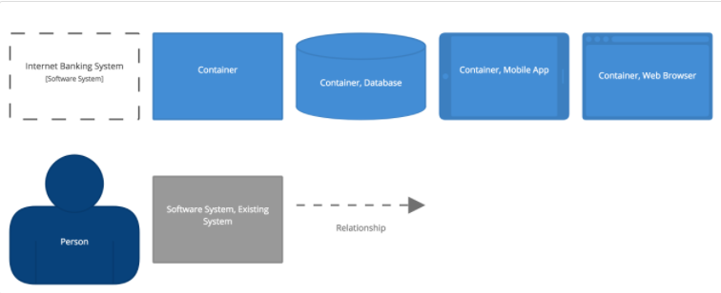

**Figure 1.2.2:** *Diagram Key/Legend*

## DOCUMENTS REFERENCES

|  |  |
| --- | --- |
| **No.** | **Reference** |
| 1 | Product Backlog Document for GB5 |
| 2 | Project Plan Document for GB5 |

# 

# PROBLEM STATEMENT

## PROJECT OVERVIEW

As well as the evolution of The Fourth Industrial Revolution (4IR) and the increasing civilization, the environment is becoming harmful by human behavior. Also, at the current rate of urbanization and industrialization, outside of the natural factors, the change of environment is mainly due to human factors. Emissions, population explosion, industrial solid waste, ... are the main causes leading to negative effects on the global environment. To reduce this at a holistic level, predicting human personality and finding the link between it and the environmental impact is the most important task that must be done.

However, predicting human personality and finding the link between it and the environmental impact from many different sources takes a lot of effort and money. To solve this problem, based on our knowledge of big data systems, we have built an intelligent data processing system that can be run on a website-platform with an intuitive and easy-to-use dashboard. This system is a prospective and useful tool for environmental experts and policy makers in Vietnam in particular, and worldwide in general. It can predict user personality and find their effect on the environment and suggest the solution to reduce it.

## BUSINESS DRIVERS

#### Business problem:

Our environment is always changing. However, at the current rate of urbanization and industrialization, outside of the natural factors, the change of environment is mainly due to human factors. Emissions, population explosion, industrial solid waste, ... are the main causes leading to negative effects on the global environment. To address this at a holistic level, find out the collaboration between human personality and environmental impact is one of the most important missions.

#### Business need:

Green Big 5 Information System have specific uses :

* Collecting user data
* Predicting user personality trait

All the things above are based on the functionality of the Green Big5 Information System. GB5 fully meets these requirements. Therefore, the development of GB5 is very necessary and meaningful.

## PROJECT GOAL

The aim of this project is to build a GreenBig5 information system (GB5), i.e. GB5 App, database and GB5 Dashboard:

GB5 App: User data can be collected and used to predict her/his personality by sending questions and receiving answers.

GB5 Dashboard: Support for creating question packages which used to direct the user follow the environment theme. With each question, users can be distributed by Indicator. Finally, by using a prediction method to predict the user's personality traits.

As a result, government authorities, enterprises, as well as users would have an overview of the environment and have a better solution to change user behaviour and to reduce and prevent it from the bad effect.

# ARCHITECTURE DRIVERS

## HIGH-LEVEL REQUIREMENTS

*(Refer to the Product Backlog document for GB5)*

## SYSTEM CONTEXT DIAGRAM

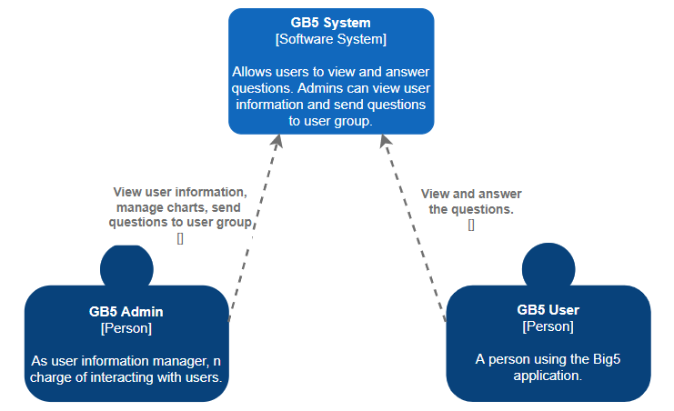

**Figure 3.2**: Context Diagram of System

## QUALITY ATTRIBUTES

|  |  |
| --- | --- |
| **ID** | **QA01** |
| **Quality Attributes** | Performance |
| **Stimulus** | Submit a question to the user group |
| **Source(s) of stimulus** | Admin |
| **Artifacts** | System |
| **Environment** | Normal mode |
| **System response** | The system displays a message that the question has been sent successfully |
| **Response measure(s)** | Within 5 seconds |

**Table 3.3.1:** *Performance Quality Attribute*

|  |  |
| --- | --- |
| **ID** | **QA02** |
| **Quality Attributes** | Performance |
| **Stimulus** | Login in to the mobile application |
| **Source(s) of stimulus** | User |
| **Artifacts** | System |
| **Environment** | Normal mode |
| **System response** | The system displays the question view page |
| **Response measure(s)** | Within 3 seconds |

**Table 3.3.2:** *Performance Quality Attribute*

|  |  |
| --- | --- |
| **ID** | **QA03** |
| **Quality Attributes** | Availability |
| **Stimulus** | Unable to import question into database |
| **Source(s) of stimulus** | Admin |
| **Artifacts** | System |
| **Environment** | Normal mode |
| **System response** | System will log the fault immediately |
| **Response measure(s)** | Within immediately |

**Table 3.3.3:** *Availability Quality Attribute*

# CONSTRAINTS

## BUSINESS CONSTRAINTS

* Project will be started on: 12 - Aug - 2021
* Project will be finished on: 15 - Dec – 2021
* Duration: 17 weeks

## TECHNICAL CONSTRAINTS

Main Programming Language: Javascripts, Dart

* **GB5 Application:**
  + Programming Language: Dart, Flutter, JavaScripts, ExpressJs
  + Tool: Android studio.
* **GB5 Database:**
  + Database: MongoDB
  + Tool:MongoDBCompass.
* **GB5 Dashboard:**
  + Programming Language: JavaScripts, ExpressJs
  + Tool: Visual studio code.

# HIGH-LEVEL ARCHITECTURE

## CONTAINER DIAGRAM

The diagram below shows the overview architecture including containers.

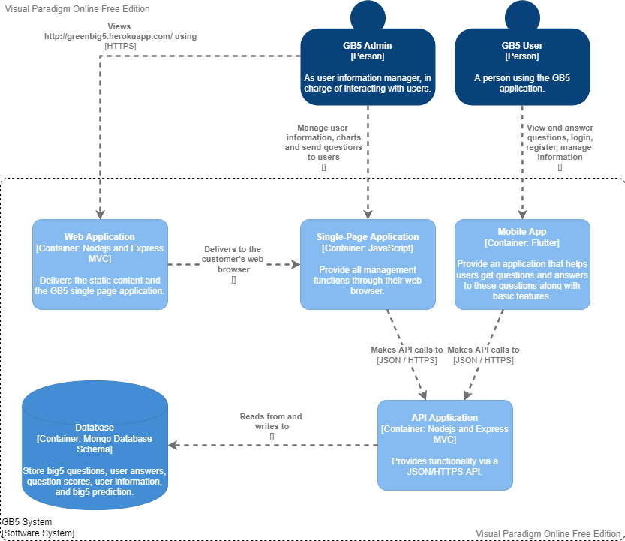

**Figure 5.1:** *Container Diagram*

## COMPONENT DIAGRAM

* + 1. Mobile Application

The diagram below shows the overview architecture including components and other related components.

## 

**Figure 5.1:***Component diagram of Mobile Application*

* + 1. Single-Page Application

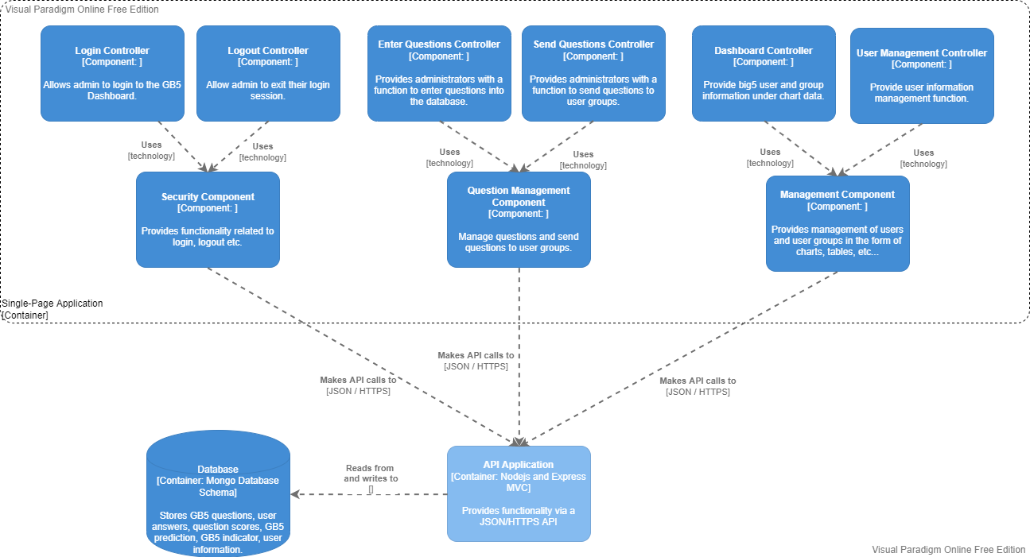

**Figure 5.2:***Component diagram of Single-Page Application*

## CLASS DIAGRAM

The diagram below shows the overview architecture including the class diagram of the question management component.

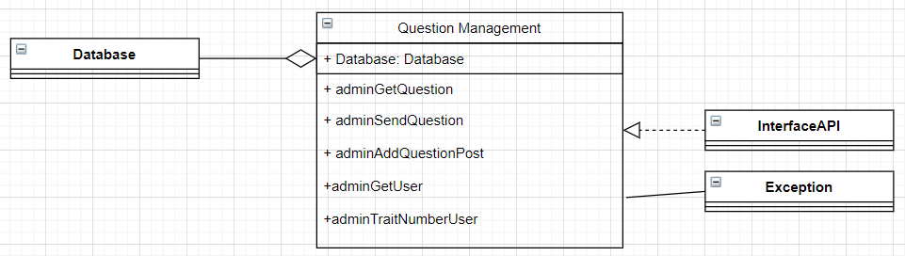

**Figure 5.3:** *Class Diagram*

|  |  |
| --- | --- |
| **Role & Responsibility** | **Description** |
| adminGetQuestion | Display questions from the database on the board |
| adminSendQuestion | Submit a question to the user group |
| adminAddQuestionPost | Enter the question into the database |
| adminGetUser | Select the User group to submit the question |
| adminTraitNumberUser | Save indicator information for group classification |

**Table 5.3:** *Role Description*

# 5.4 Allocation Diagram

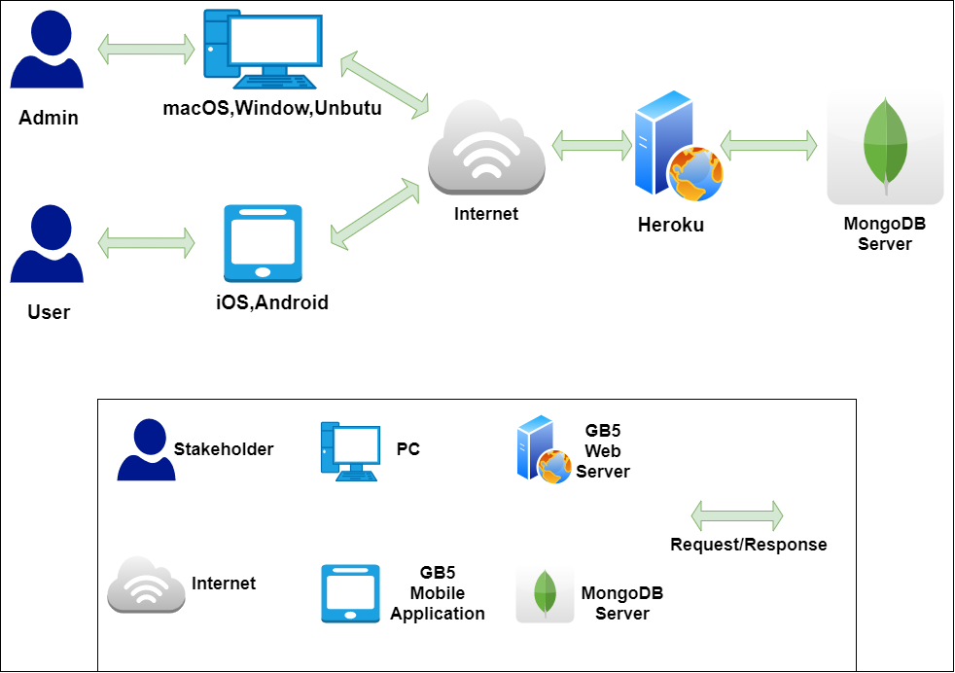

**Figure 5.4:** *Allocation Diagram*

|  |  |
| --- | --- |
| **Role & Responsibility** | **Description** |
| Admin | Admin that interact with Dashboard Application. |
| User | User that interact with Mobile Application. |
| PC | Devices providing web browsers. |
| Mobile Application | Our application. |
| Internet | A global computer network providing a variety of information and communication facilities, consisting of interconnected networks using standardized communication protocols. |
| GB5 Web Server | This is where the API is hosted and provides hosting... |
| MongoDB Server | Database server to store data. |
| Request/Response | Get request data from client and response the data to client. |

**Table 5.4:** *Role Description*

# REFERENCES

* [The C4 model for visualising software architecture](https://c4model.com/#Metamodel)
* <https://online.visual-paradigm.com/>
* [diagrams.net](https://app.diagrams.net/)